**ENED 1100 – Fall 2021**

**Homework 3.1**

Submit to your Canvas **Section Site** by Sept 16th at 7:00pm

**Individual Assignment:** See the course syllabus for a definition of what constitutes an individual assignment.

You may either scan or image your handwritten solutions or use the tools provided in Microsoft Office and Excel to generate the charts and diagrams below. If you scan or image your handwritten work, please insert the images generated into the provided Word document for submission purposes (3p1_HW_ProjManagementSystemsThinking_SubmissionSheet.docx). When completed with the assignment, submit your documents to your Canvas Section Site using the following file name:

**HW_3p1_UCusername.docx** or **HW_3p1_ UCusername.pdf**

where *UCusername* means your UC 6+2 username

Task 1 (of 2):

Insert Precedence Network Diagram and Identification of the Critical Path here:

Insert Gantt Chart here:

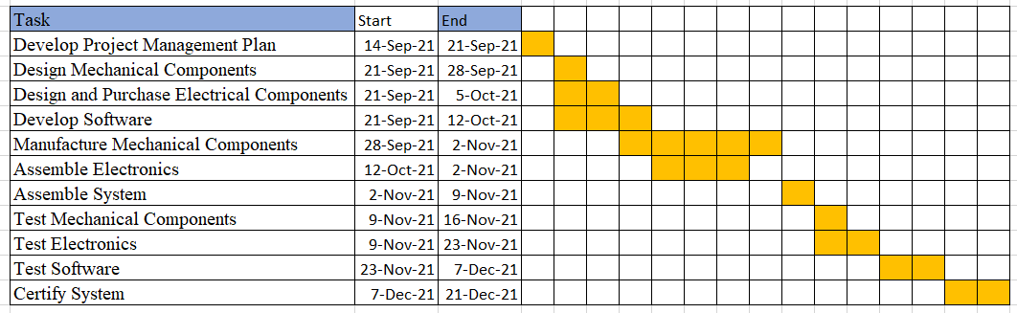

**TASK 2 (of 2):**

* 1. Identify a list of possible customers/stakeholders.

|  |
| --- |
| Type answer here: Customers would most likely be found in places that see a large number of people during the day, such as airports, malls, and stores, where many people would prefer to wash their hands after pressing a door or button. Hand sanitizer companies, as well as the general public, would be stakeholders, as they would be the ones using the dispensers. |

* 1. What are the constraints and criteria?

|  |
| --- |
| Type answer here: A touchless hand sanitizer dispenser's criteria include how it's powered, how much it costs, how easy it is to use, and how it looks. Constraints include how the product must be powered, as batteries are inefficient for these machines and reusable energy is also impractical. |

* 1. What are the input(s) and output(s)?

|  |
| --- |
| Type answer here: The product's inputs would be the electricity needed to power the gadget and the motion of the hand, while the sanitizer would be the output. |

* 1. Insert Functional Block Diagram:

